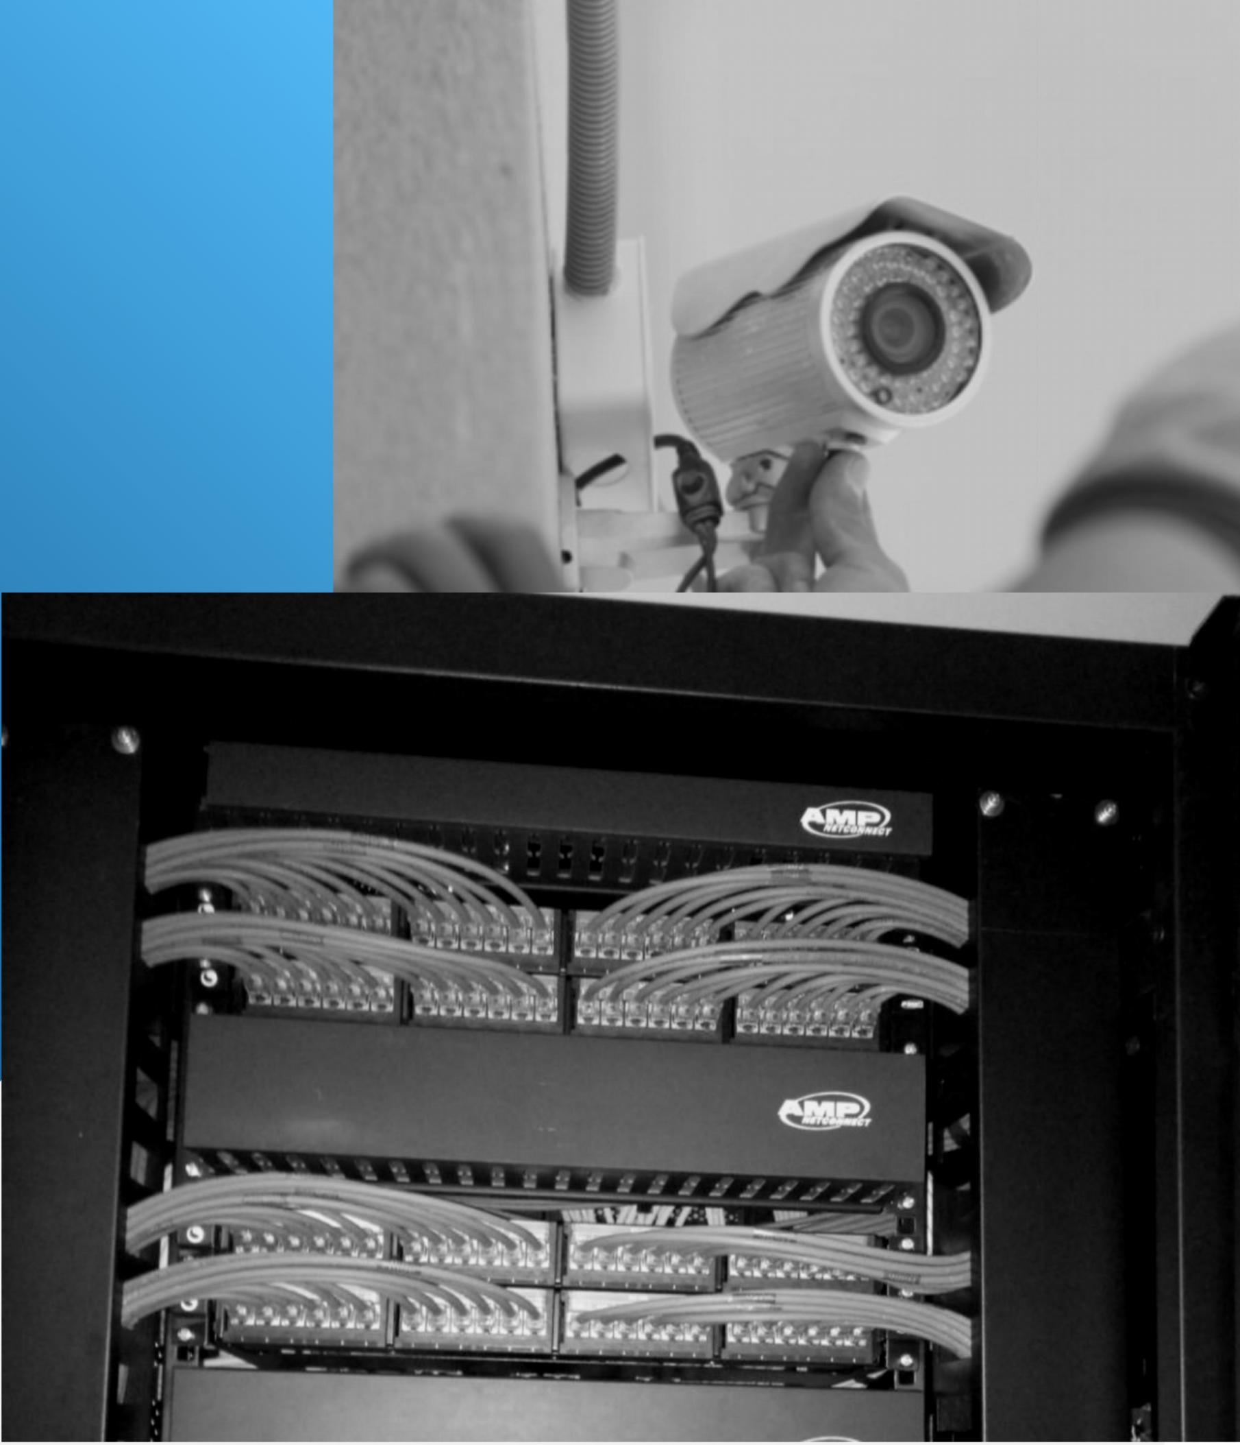



Company Overview

Aimvest Electrical Services was established in June 16 2021. It is located at Daang Hari Street,Sitio Taghangin, Barangay Maybancal, Morong, Rizal.Currently, the company is headed by the President/CEO Mr. Andy L.. Pagpaguitan ,and Vice President, Mrs. Thonielyn B. Pagpaguitan. The company’s team is composed of professional who provide 24-hours, 7days a week service. Aimvest Electrical Services staff are well-trained and knowledgeable on major system and software, also has technically participated in various tenders and negotiation with primary objective of meeting the increasing demand of communication system, construction and electrical power services. The company is an Electronic Security Service Provider that specializes in Electronic Security, Access Control, PABGM, CCTV Systems, Structured Cabling, Electrical Services and Building Constructions works. Our company, Aimvest Electrical Services can arrange service and maintenance agreements which are individually fitted to meet the specific requirements of every client.

Vision

To be a company well-known nationwide, to continuously deliver quality services and products, and to also provide the best, long-term solutions that answer our customer desires.

Mission

To develop long term partnerships with our business partners, to provide effective and reliable information technology solutions that will provide a cost- effective service to all of our clients with highest level of satisfaction

Our Commitment

On behalf of Aimvest Electrical Services, we thank you for showing interest in our company and allowing us to connect with you. We are committed to service excellence and, in an ever trying and challenging environment, our focus is directly on our internal and external partners. Such as, our employees and business partners. Success relies on service delivery on both counts and in so doing, we respect our partners and delight others as we would like to be delighted. We are a professional company with the resources to meet the commitments given in this company profile. We custom build your Security Systems to specifications whether in Retail, Industrial, Residential,Commercial Establishment and Financial Sectors etc. Aimvest Electrical Services assures timely response to customer service, user- friendly equipment, top class technical personnel support and an outstanding warranty and service scheme.

## Contact and Information

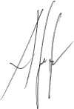

**Andy L. Pagpaguitan**

President / CEO

Cellphone No: 09276145522 (Globe)

09501430188 (TNT)

Email Address: [andypagpaguitan@gmail.com](mailto:andypagpaguitan@gmail.com)

[aimvestelectricalservices@gmail.com](mailto:aimvestelectricalservices@gmail.com)



*Aimvest Electrical Services* offers special services to clients who are mostly large and medium scale Commercial Establishments, Industrial Plants, Instrumentations and Controls, Communication System, Electrical Power System services and Building Construction.

*SERVICES:*

1. Data and Voice Structured Cabling Installation
2. Electrical, Lighting and Power System Services
3. FDAS Installation Services
4. CCTV System Installation Services
5. PABX System Installation Services
6. PABGM System Installation Services
7. RFID and Turnstiles System Installation Services
8. Fiber Optic Installation Services
9. Feeder Lines, Wire ways and Cable trays installation Services
10. Solar Power System Installation Services
11. . And Other related Communication and Electrical Works.



**PCAB**

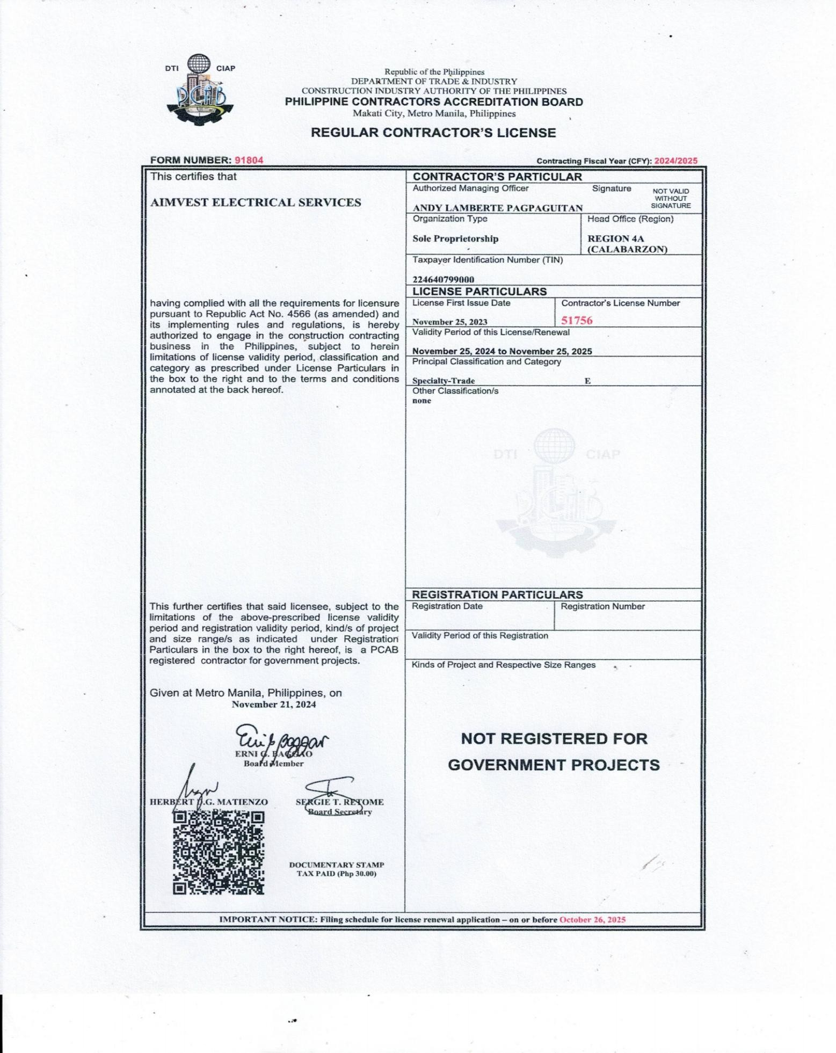



# Business Name - DTI

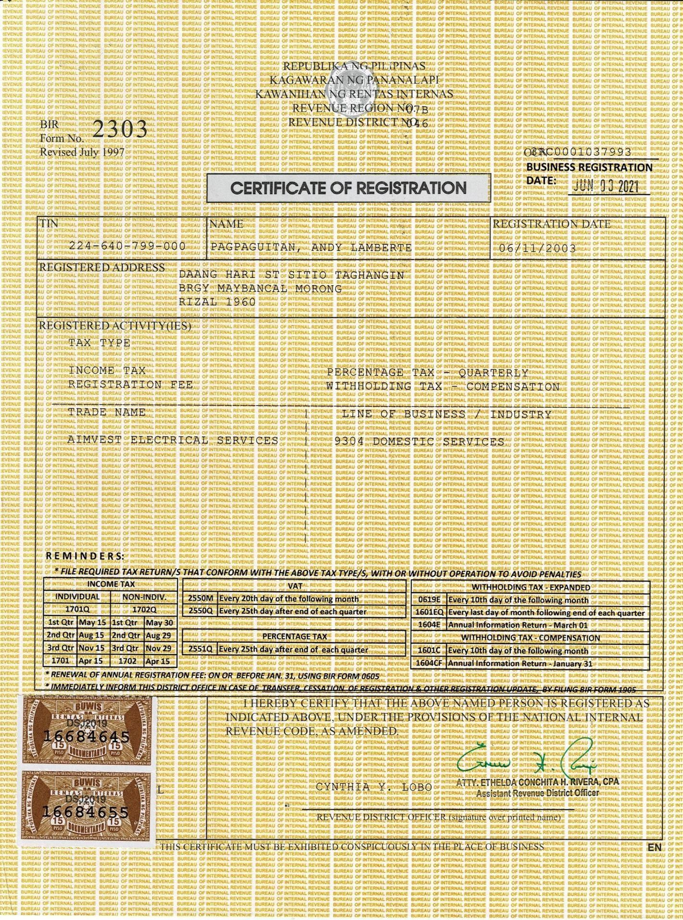

**Certificate of Registration – (COR)**

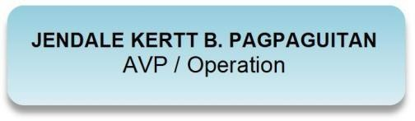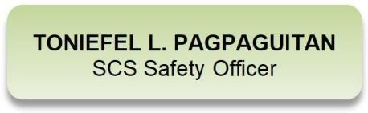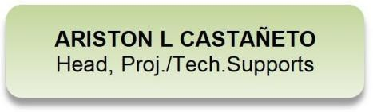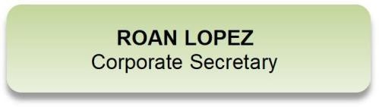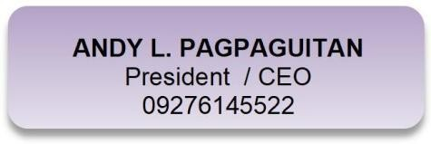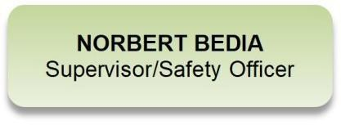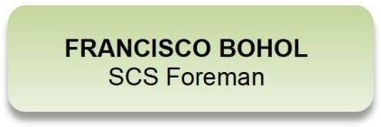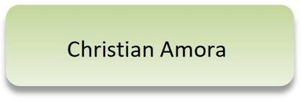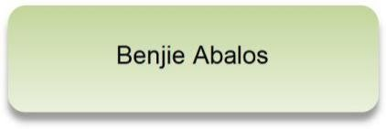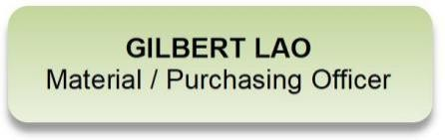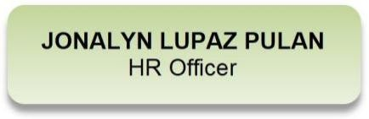

**ORGANIZATIONAL CHART**



Product List

A.) **CCTV Surveillance Cameras**

* Hikvision, * Dahua * Honeywell * Lilin

# FDAS - Fire Detection Alarm System

* + Honeywell, * Hochiki * Bosch
  + Teledata One, * Asenware * Protec

# Biometric/RFID Card Time Attendance and Access Control

* + Honeywell
  + ZKTeco

# Public Address Background Music (PABGM)

* + Honeywell
  + TOA

# STRUCTURED CABLING (UTP and Fiber Optic)

* + Belden * LS Cable
  + Panduit, * Alantek
  + Comscope

# Private Automatic Branch Exchange (PABX) / Intercom System

* + Panasonic
  + Aiphone
  + Grandstream (IP PBX)

# Others:

* Data Cabinets
* Raised Access floor
* Solar Installation
* Etc.

Installation Capabilities

Aimvest Electrical Services performs maximum in-house installation work, with the majority if installations performed by our well-trained technicians who are experienced in the field of Security Systems and Electrical Projects undertaken by Aimvest Electrical Services, are completed within the program time limits, on budget and all snags completed. Aimvest Electrical Services allocates all projects undertaken to a specific Head of Operation and Head of Technical personnel who is responsible for the project from the concept of handover.

Maintenance and Servicing Capabilities

Aimvest Electrical Services has a standard call-out procedure for each system installed. Aimvest Electrical Services endeavors to respond telephonically within the hour and on site within 24 hours of being notified. Qualified and well-trained technicians would respond to the specific project with the necessary tools and stocks to attend to the faults, should the system require additional spares, these would be obtained within the shortest time required. Servicing of equipment is carried out by Aimvest Electrical Services either on the site or in- house.

Aimvest Electrical Services undertakes after sales service agreements and pride in the in-depth knowledge of its product base with central documentation for each project undertaken. Quality is an element of the attitudes of our well-technicians that has been carefully nurtured and is evident in the compliments received from clients.

Service Quality

Aimvest Electrical Services strives for excellence and continuous improvement and in so doing it is policy to formulate “Quality Management Systems‟ specifically aimed at each business partners‟ unique requirements rather than via a generic approach. The company also utilizes a customer satisfaction questionnaire to determine service standards which complements existing service level agreements used by business partners, this is focused on direct service delivery by personnel on the ground, management and supervision.

CCTV Surveillance Cameras and Installation

Closed-circuit television (CCTV) cameras can produce images or recordings for surveillance purposes, and can be either video cameras, or digital stills cameras.

Video cameras are either analogue or digital, which means that they work on the basis of sending analogue or digital signals to a storage device such as a video tape recorder or desktop computer or laptop computer.

The Company’s policy is to select only the highest quality equipment for any specific requirements. Aimvest Electrical Services are accredited partners with the suppliers of the most advanced Closed Circuit Camera equipment in the world and install, supply and commission CCTV Systems for a wide variety of clients. Aimvest Electrical Services include full integration with access management systems, with matrix switchers, multiplexers and digital recording based platforms. These systems have been installed for various clients eg. Shopping Centers, Factories, Offices and many other Commercial and Government and Residential installations.



Biometric/RFID Card Time Attendance and Access Control

Access Control Access Control Systems can be stand alone or PC based, with proximity and Smart Card/ Card Readers. The Company has installed a variety of Access Control Systems from single door to multi door. Aimvest Electrical Services can provide a system to control all aspects of personnel movement. The recording of transactions through doors, gates, turnstiles or elevators is easily accomplished. Automatic control of lighting and air-conditioning can also be achieved. Aimvest Electrical Services technicians have extensive experience with a number of different systems.

Public Address System

In an emergency situation communication is vitally important. The public address an evacuation systems provide the facility for pre-defined audible warnings and announcements. The systems can also be used for general information announcements.

Voice and data Structured Cabling

By providing professional and reliable low-voltage cabling installation for commercial properties and businesses, Aimvest Electrical Services Voice & Data has as a premier provider of voice and data cabling. Servicing businesses throughout the projects, our engineers are equipped with the experience and professionalism to exceed all your low- voltage needs.

Maintenance

Aimvest Electrical Services can arrange service and maintenance agreements which are individually tailored to meet the requirements of each client. Our existing clients includes, Government Departments, and Commercial enterprises. Aimvest Electrical Services maintains an extensive spare parts inventory to ensure, that in the unusual event of component failure, our customers don’t suffer any considerable down time. This contingency allows for the immediate replacement of any failed system component. The Aimvest Electrical Services teams, all have the knowledge and equipment to enable them to service and maintain all of the products we deliver.

Accomplished Works

Koten Enterprises

Contact Person: Doles, Lex Jhederene

Address: 1959 FB Harrison St. Pasay City

Contact No.: +639998813013

+6322415250

Fax No.: +6327116087

Email: [koten.ljdt@gmail.com](mailto:koten.ljdt@gmail.com)

Scope: Electrical Installation and Termination Documentation:

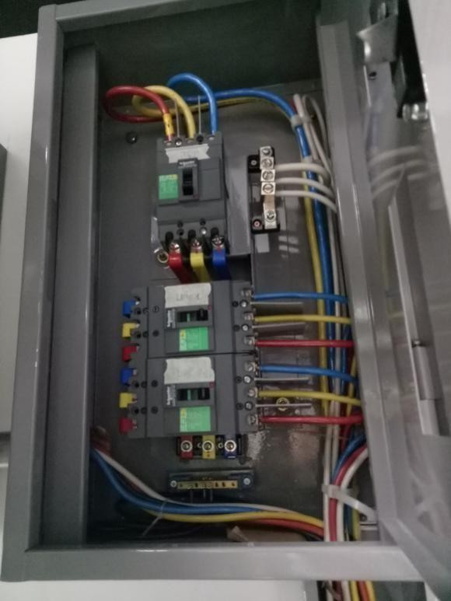 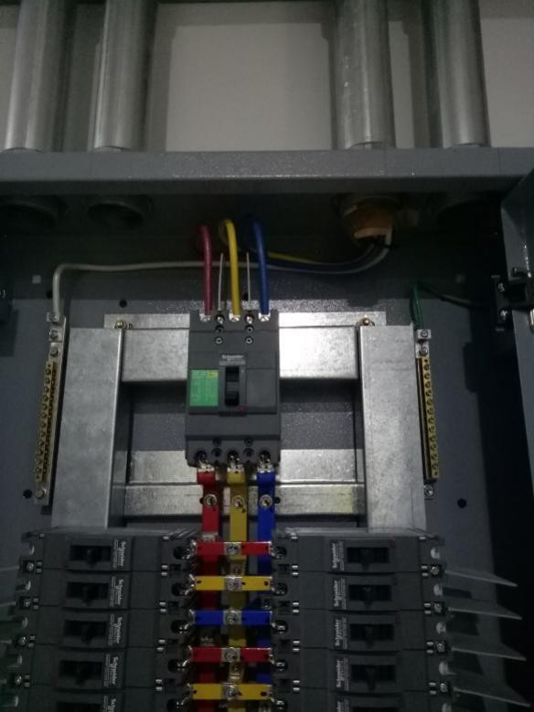

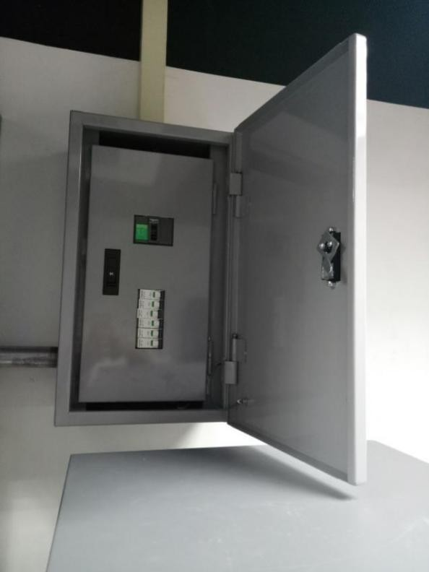

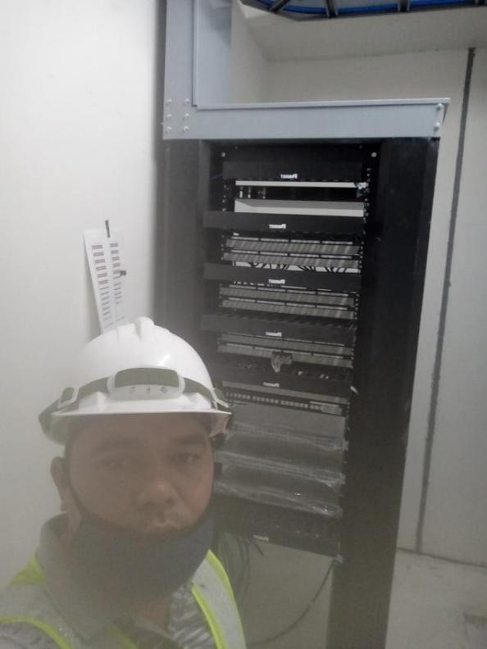

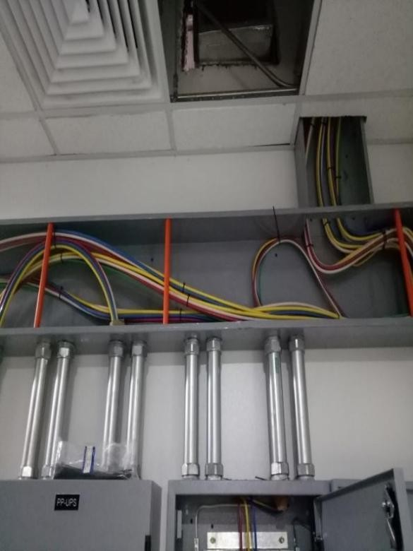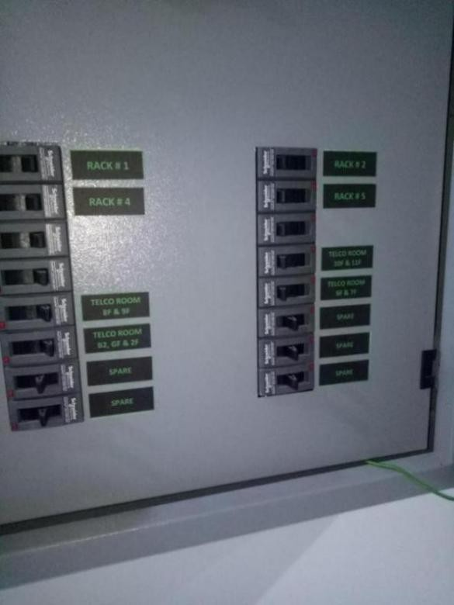

Velocity Office Solutions (SERVICES)



Contact Person:

Dennis B. Baello

Address: 428 Baello Bldg. A. Mabini St., Caloocan City

Contact No.: +639178064671

+639328893113

+639989533744

Email: [velocitysolutionbuilders@gmail.com](mailto:velocitysolutionbuilders@gmail.com)

Scope: CCTV (Analog and IP Based), Network Integration, Software Development, Voice and Data Structured Cabling, and Maintenance

Project Done: Shop wise Store, Rustan Store,SM San Pedro,SM Molino SM Cubao, Documentation:

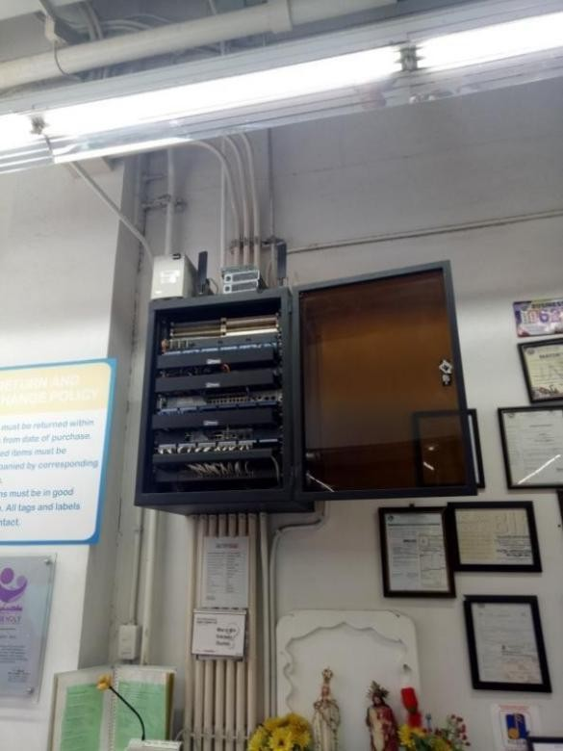 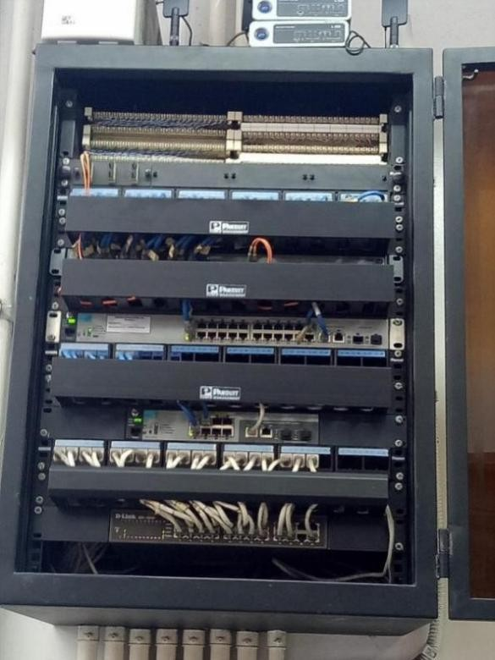



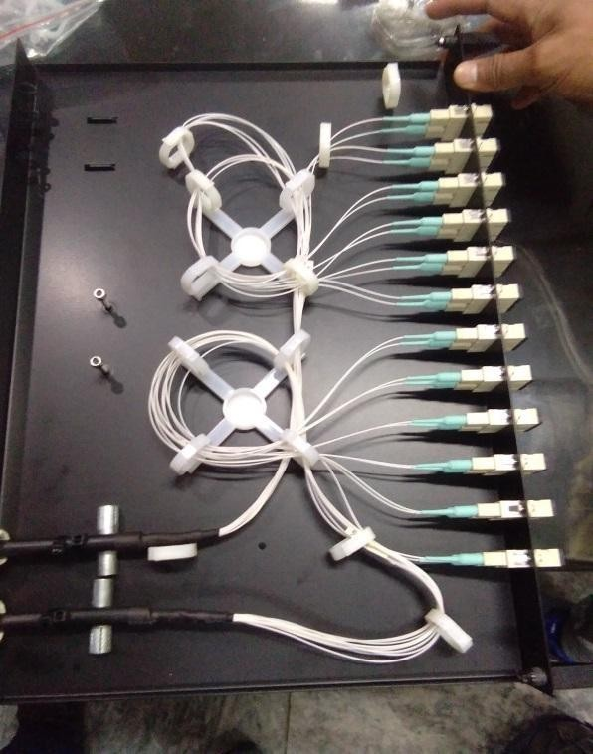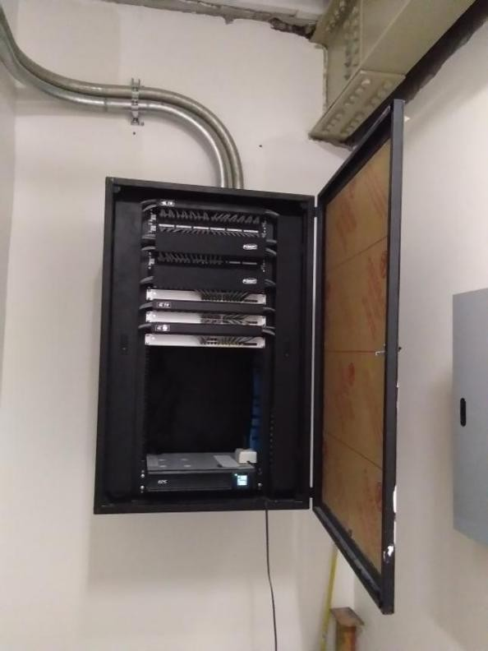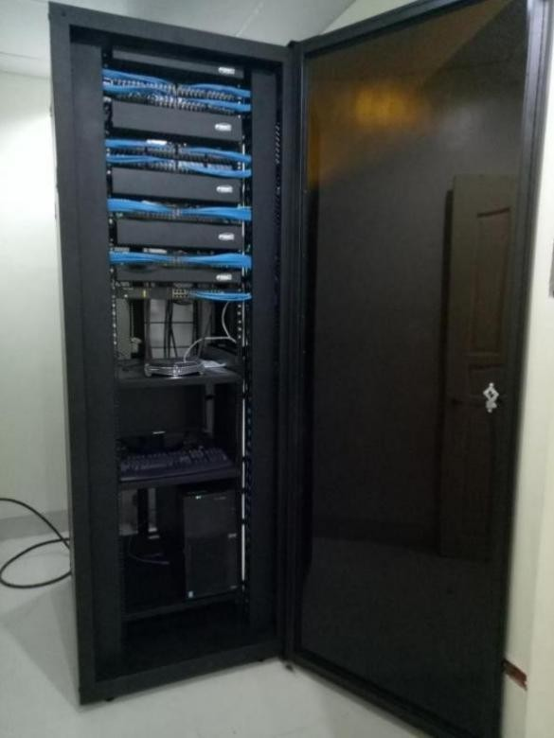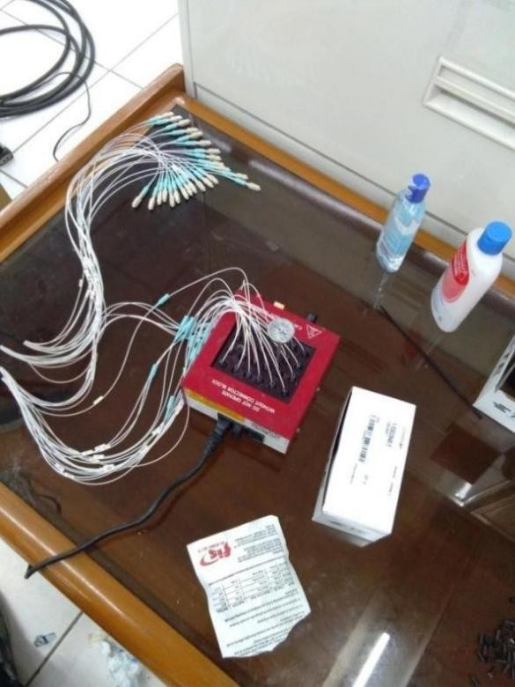

Phoenix Enterprises (SERVICES)

Contact Person: Regienald S. Victorio Address: 590A. Mabini St., Caloocan City Contact No.: 09494724066

09155646324

Tel. No.: (02) 935-9981

Fax No.: (02) 294-6955

Email: [phoenix_enterprise@yahoo.com](mailto:phoenix_enterprise@yahoo.com)

Scope: Wiring Installation and Activation of Fire Alarm, WIFI, CCTV, Telephone, Door Access, Paging System

Documentation:

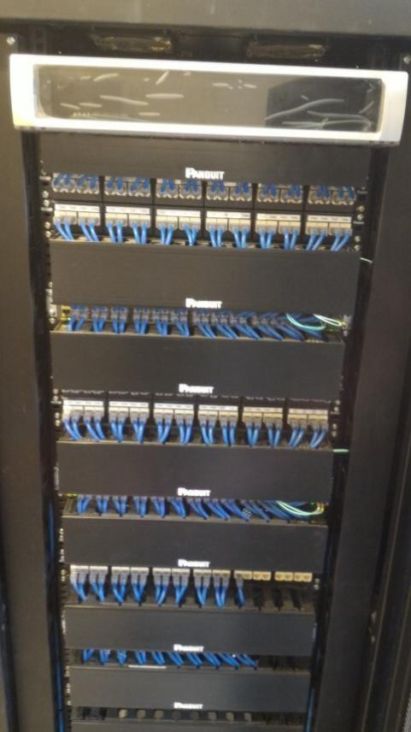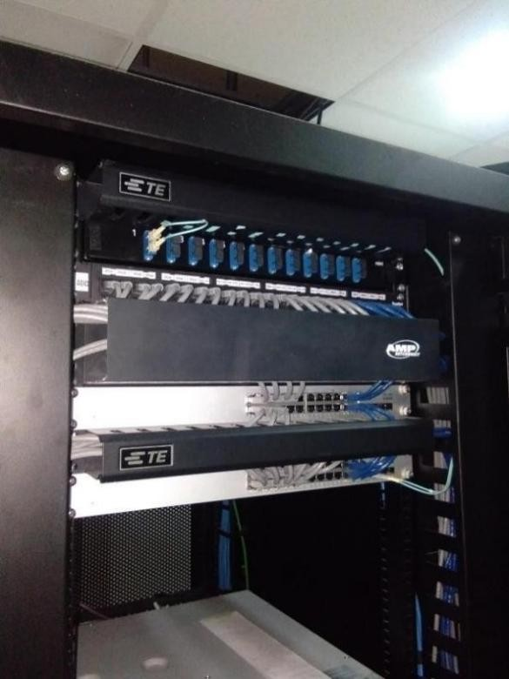

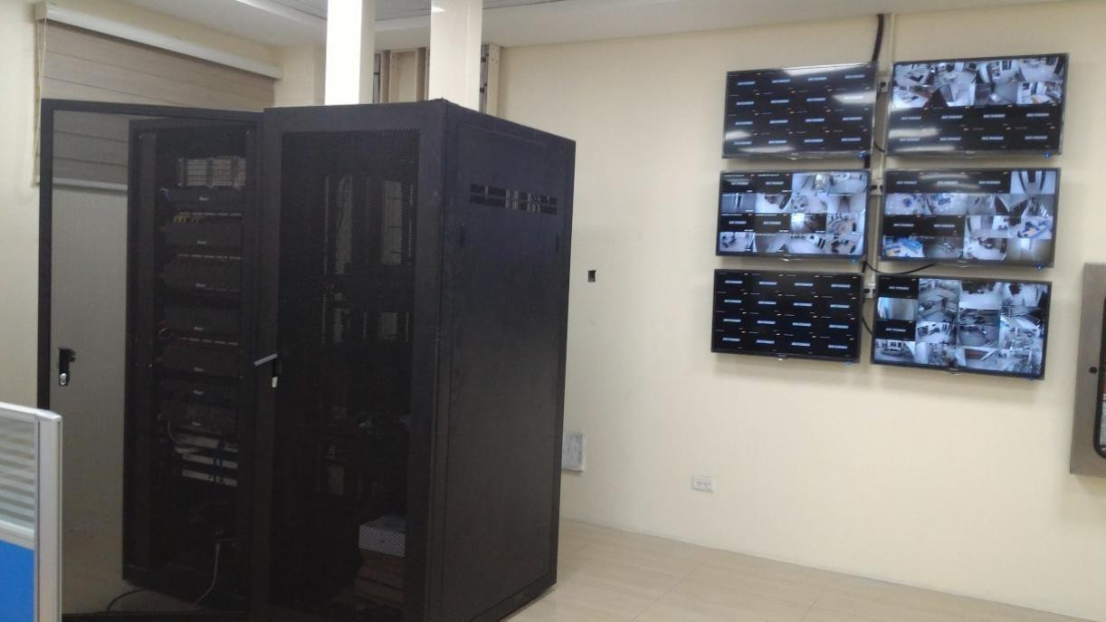

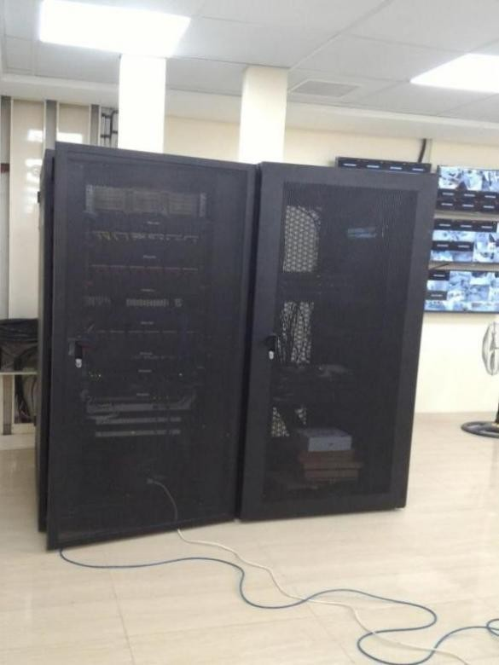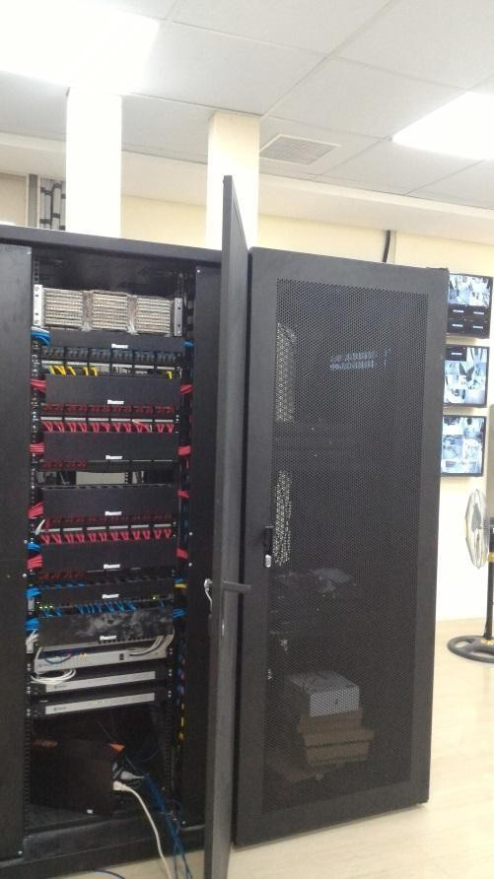

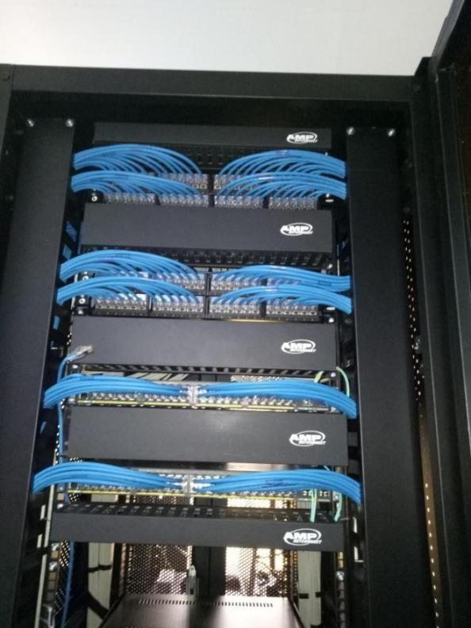

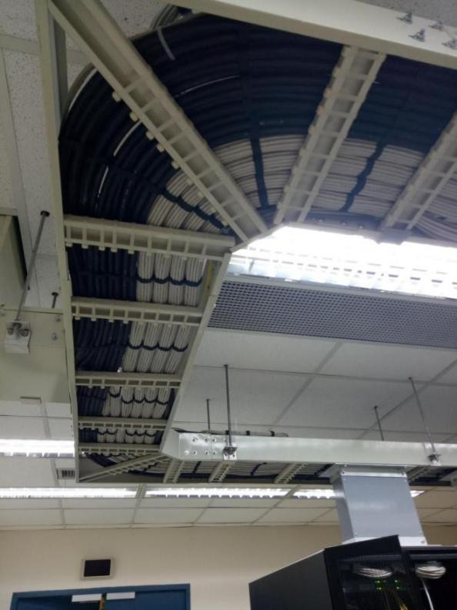

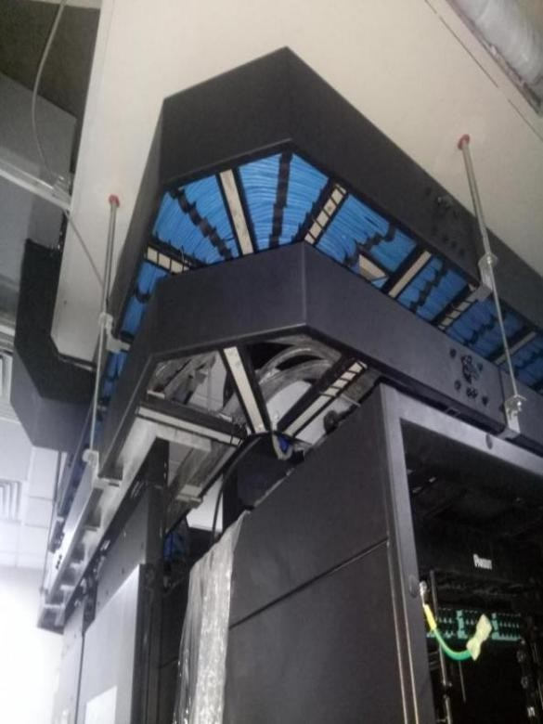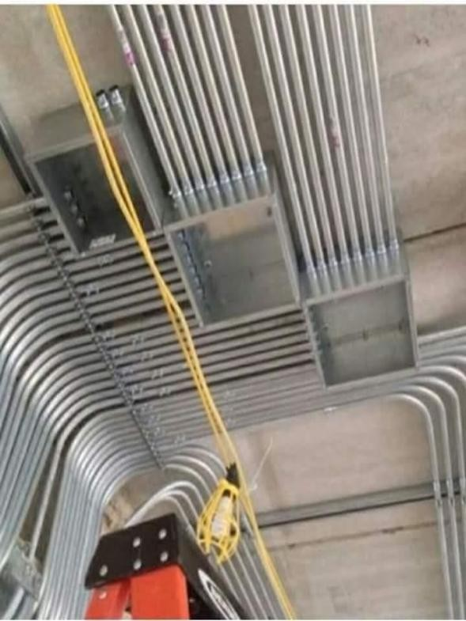

## St. Lukes College of Medicine Building

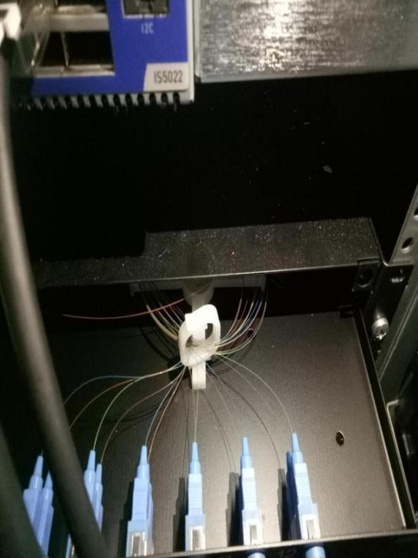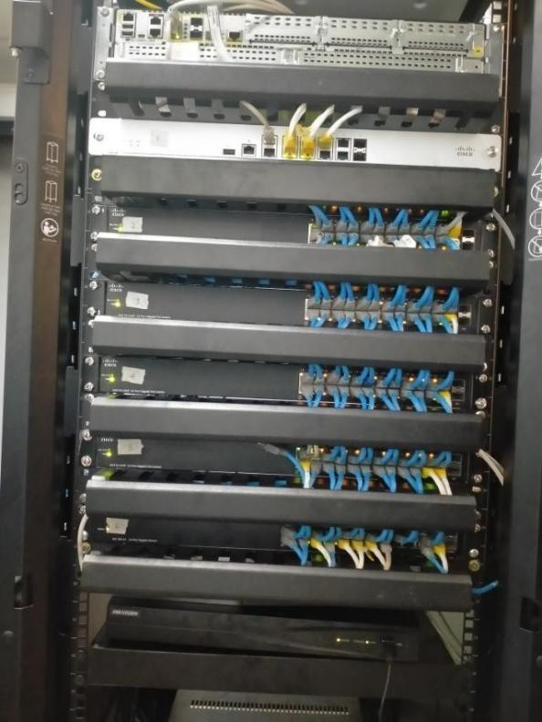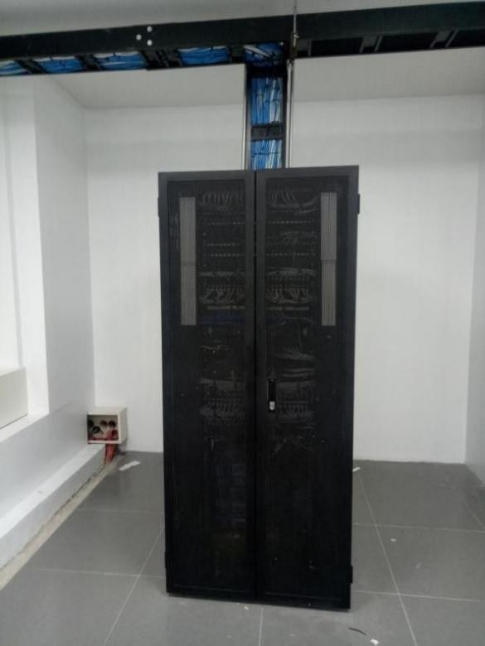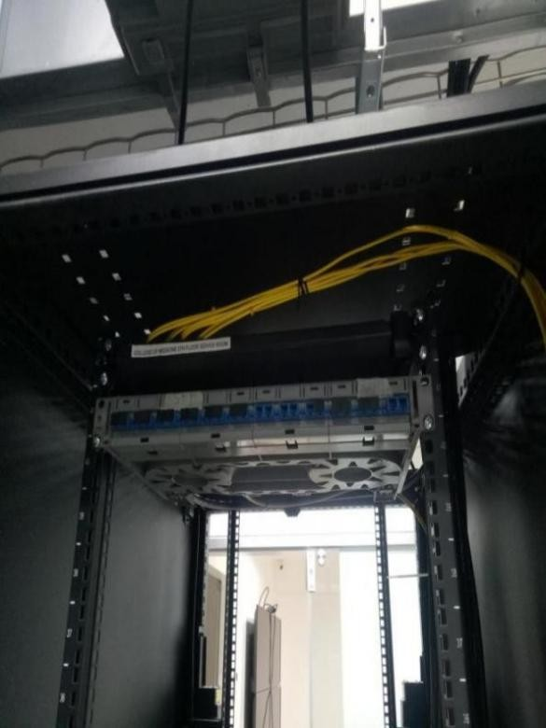

Technology Specialist Inc. (TSI)

* Ten Knots Dev
* Petron
* PSSLAI
* TELSTRA
* Sevina Una Apartment
* Metrodrug
* JTI Lima batangas

## Projects handled:

* TEE / ATI Technologies
* DDT Pasay
* PAL Airport and CMD Office ,FOFTA
* Megaworld Office Eastwood Libis
* NTT Building Makati
* Pharma Nutria Bacolod
* Alphaland Baguio
* GBOS Libis
* Emerson Megaworlod

-Epson Batangas

-Optum BGC/Quezon City/Cebu

* + On Semicon Cavite &Tarlac - Integreon Makati -ENT 2Iloilo
  + Metrodrug
  + CIP Makati
  + Lunbeck Phil. Inc.
  + PLDT Makati

-Unilever Cavite & Cabuyao

* + Suthernland tarlac & Makati - Welthmore Tondo -SMB Daraga
  + Department of Agriculture - Megaworld Ilo Ilo -DHL Batangas

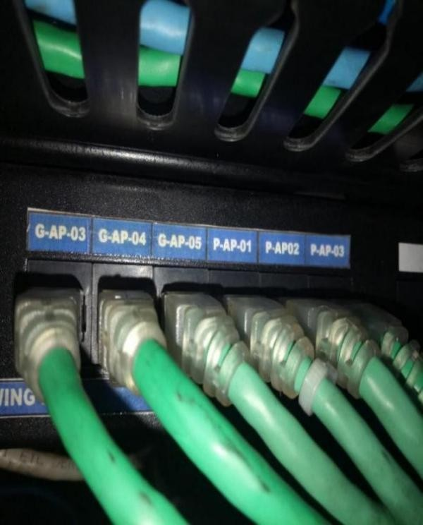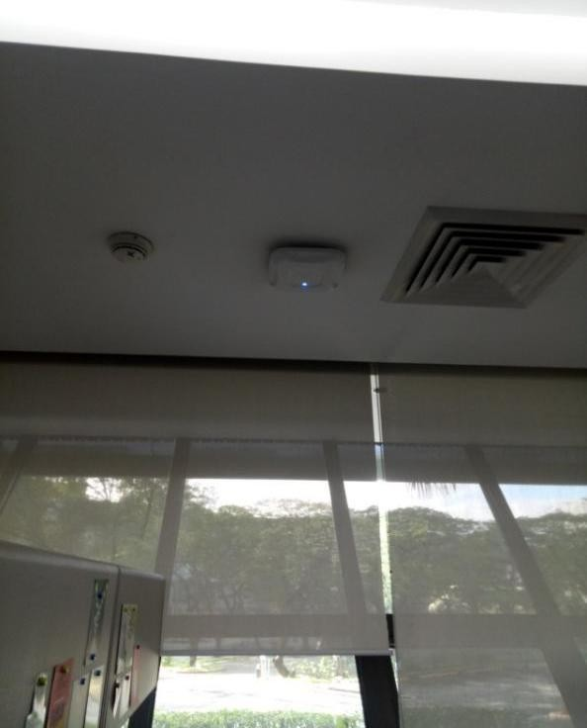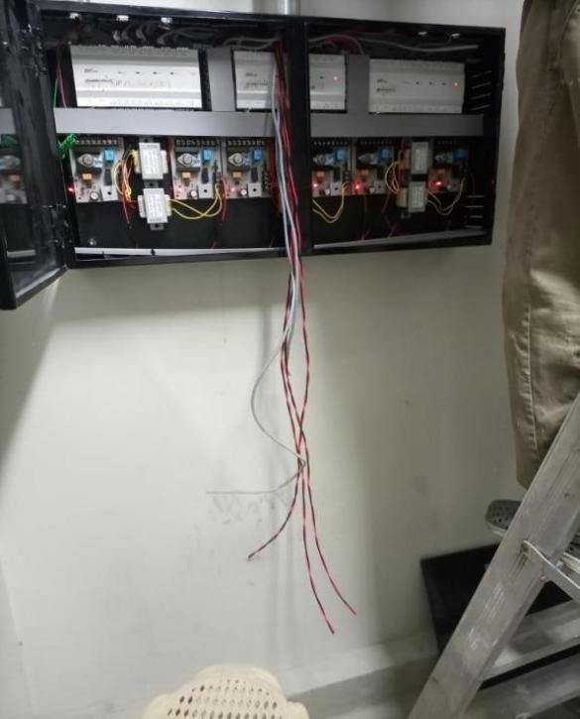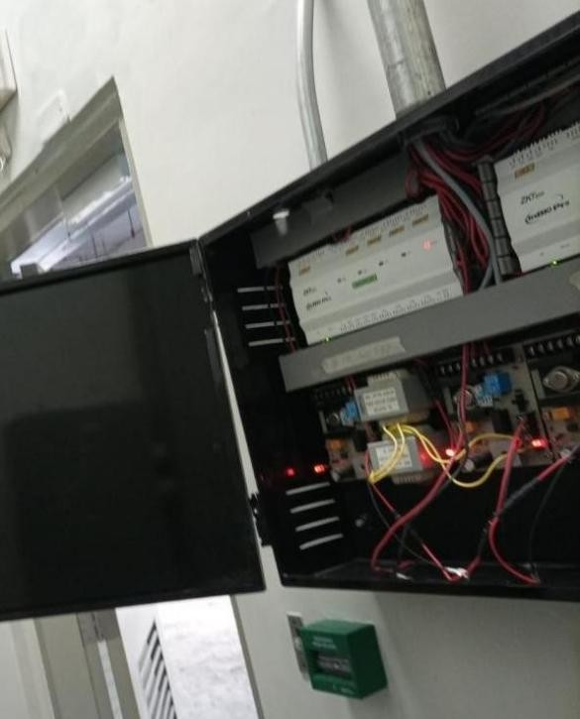

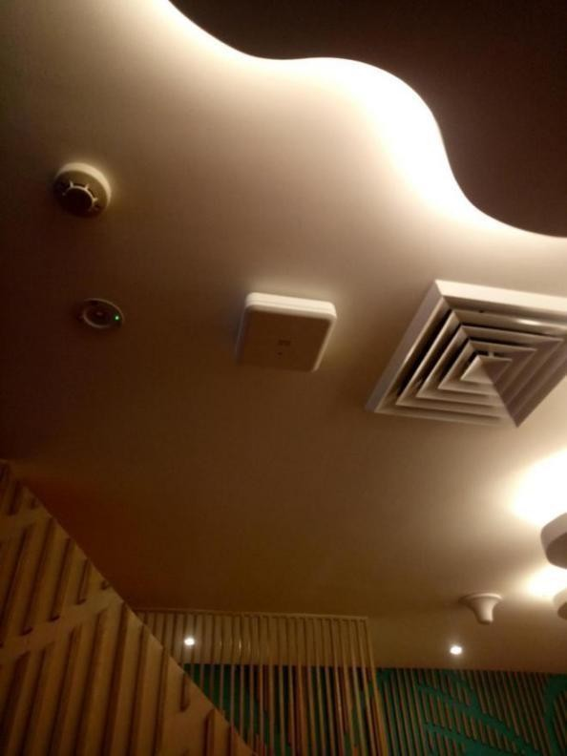

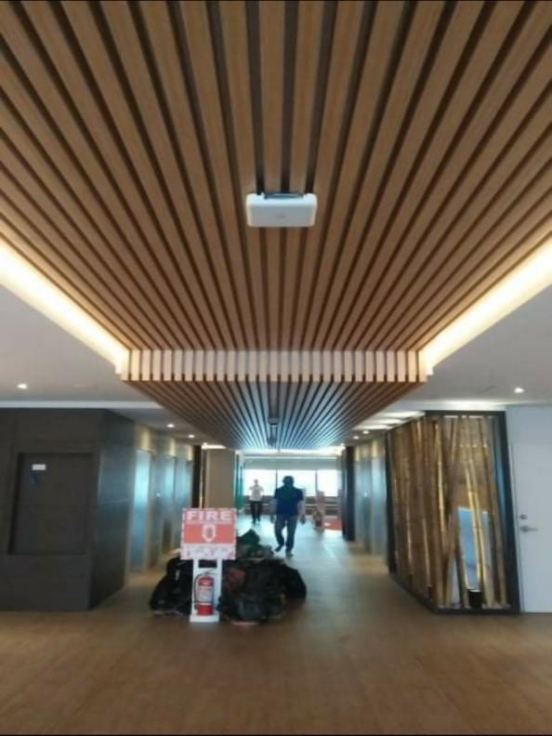

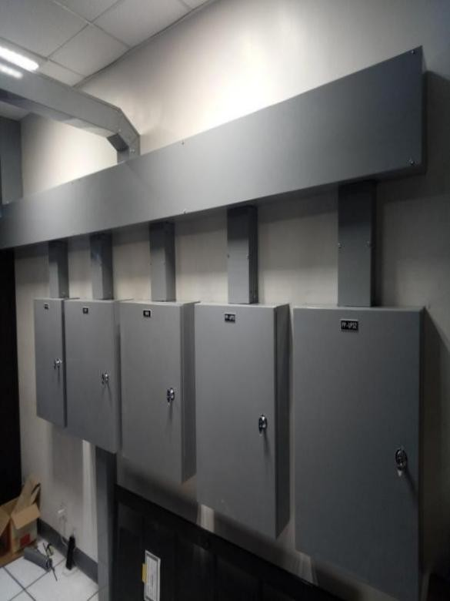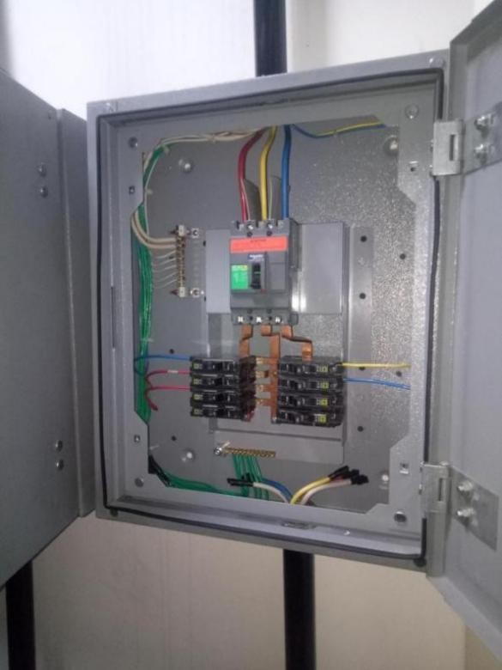

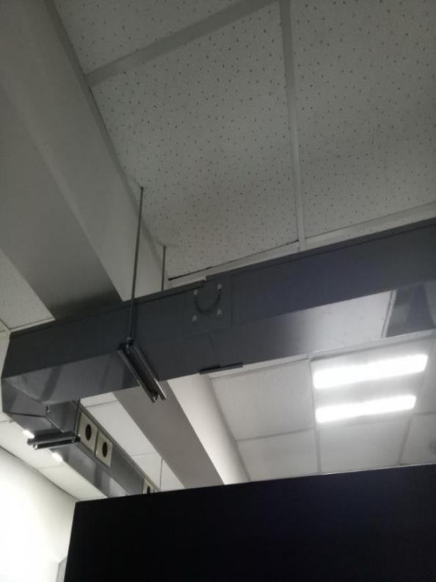

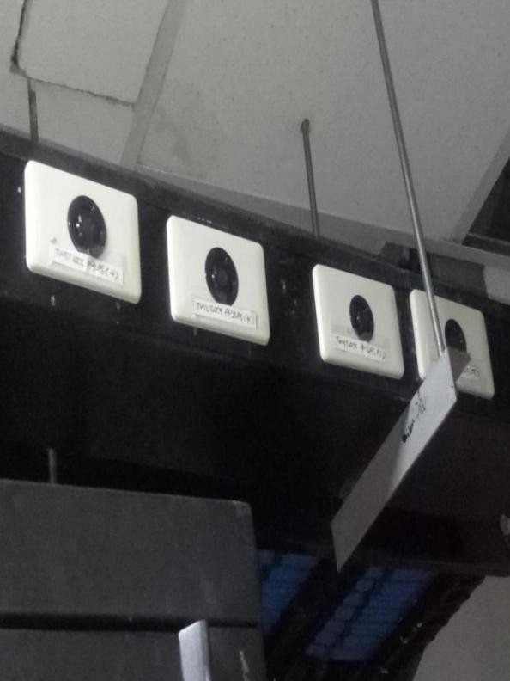

Intellismart Technology Inc. (SERVICES)

## Projects handled:

* + Monolith GSC Tower - Red Residence Makati
  + Morning Star Pasig - Lf Logistic Warehouse
  + San Antonio (Megaworld Corp.) - Phirst Park Baluag,Trece,Batulao,Bataan,
  + Urban Recidences Building - Phirst Park Gapan,Tayabas,
  + Phirst Park Magalang
  + Tim Hortons NLEX
  + Kingsford Hotel
  + Harvesta Tarlac
  + Mezza Residence Building
  + Steel Asia (Calaca Batangas)



**Documentation:**

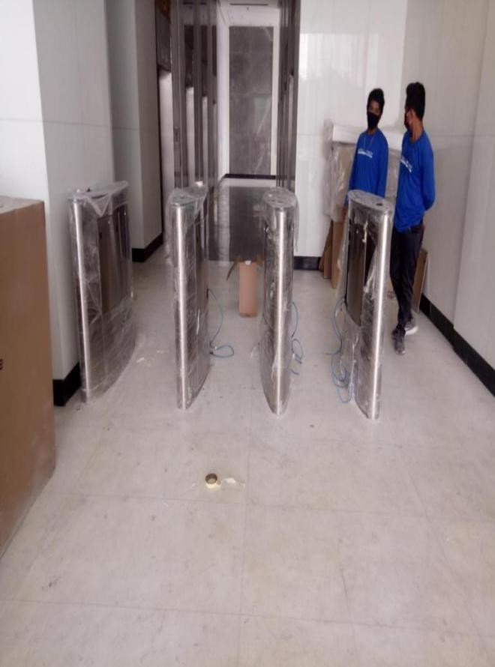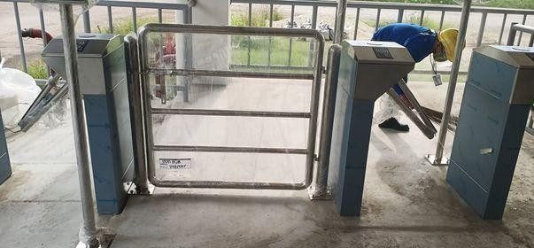

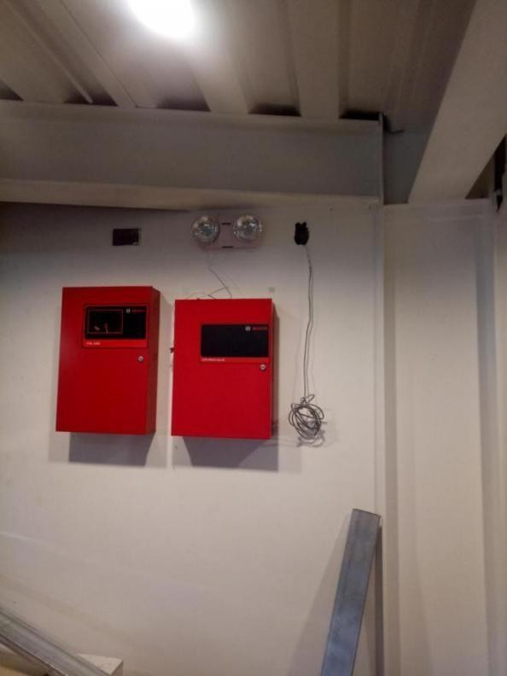

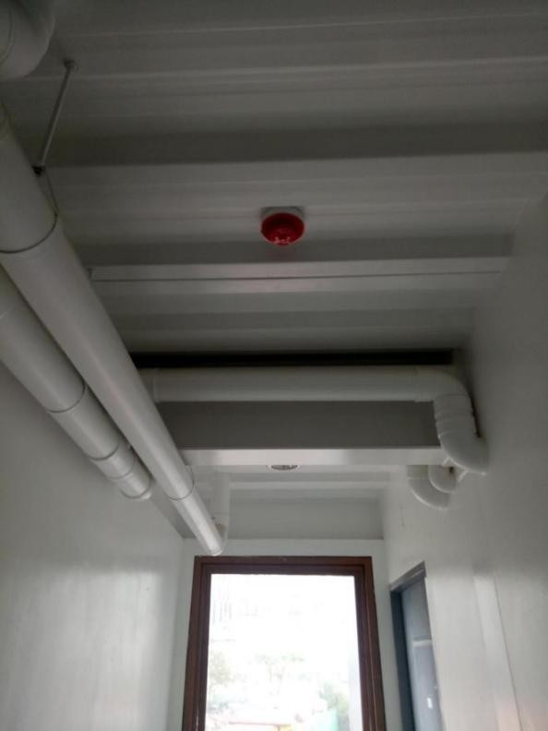

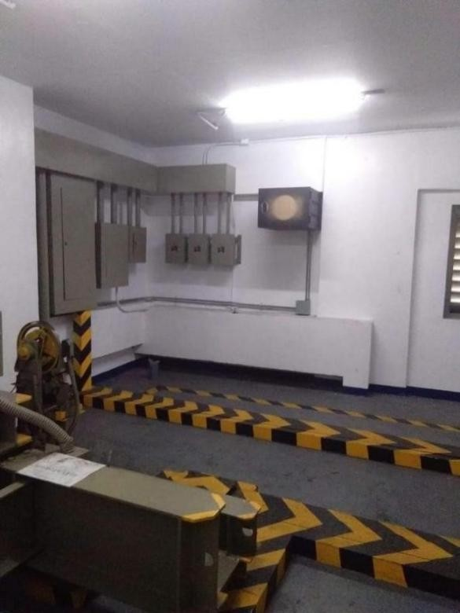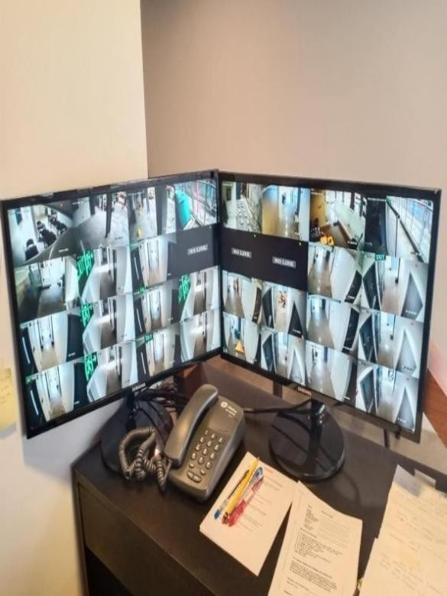

**Pictures of Electrical and Solar Installation Works**

